**Introduction to Experimental Error**

**Random Vs Systematic**

* **Random Errors**: Errors in that produce inconsistent measurements (poor precision).
* **Systematic Errors**: Errors in measurement that produce a consistent bias (poor accuracy).

|  |  |
| --- | --- |
| **Random Error** | **Systematic Error** |
| * Poor precision | * Poor accuracy |
| * Not reproducible | * Reproducible |
| * Can be reduced by averaging multiple readings, but never completely eliminated | * Can often be reduced or even eliminated by proper calibration, or taken into consideration in calculations. Not reduced by averaging multiple readings. |
| Examples:   * limitations of measurement instrument * human reaction time (if recording time) * difficult in judging between graduations | Examples:   * Instrument zeroing errors * poor instrument calibration * consistent parallax error |

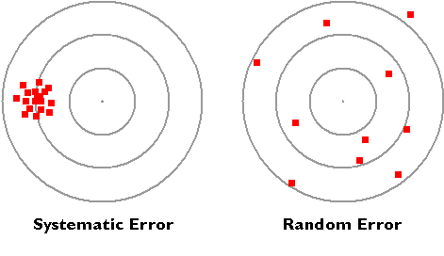

**Accuracy Vs Precision**

* **Accuracy** refers to the closeness of a measured value to the “true” value. Poor accuracy is often caused by systematic errors.
* 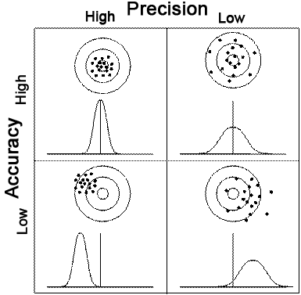**Precision** refers to the closeness of two or more measurements to each other. Poor precision is often caused by random errors.

The goal in a chemistry experiment is to eliminate systematic error and minimize random error to obtain a high degree of certainty.   
Removal of uncertainty results in [accuracy and precision](http://www.ausetute.com.au/precision.html).

**Graphing Error**

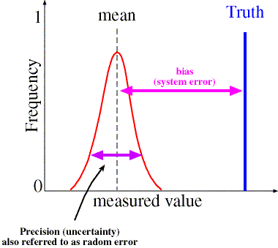

**Mistakes**

Mistakes are not considered experimental errors.

It is assumed that if an experimenter has made a mistake, then he/she will discard the results of the experiment and start again.

Examples of mistakes

* using the wrong reagents
* using the wrong technique
* spilling the sample
* misreading the numbers on the scale